Zero Discrimination Day

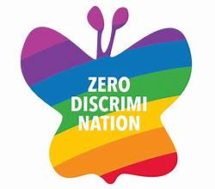

On Zero Discrimination Day this year, UNAIDS is highlighting the urgent need to take action to end the inequalities surrounding income, sex, age, health status, occupation, disability, sexual orientation, drug use, gender identity, race, class, ethnicity, and religion that continue to persist around the world. Inequality is growing for more than 70% of the global population, exacerbating the risk of division and hampering economic and social development.

And COVID-19 is hitting the most vulnerable people the hardest—even as new vaccines against COVID-19 are becoming available, there is great inequality in accessing them. Many have equated this to vaccine apartheid.

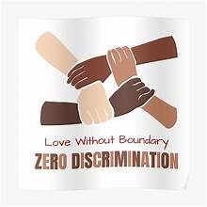 Confronting inequalities and ending discrimination is critical to ending AIDS. The world is off track from delivering on the shared commitment to end AIDS by 2030 not because of a lack of knowledge, capability or means to beat AIDS, but because of structural inequalities that obstruct proven solutions in HIV prevention and treatment. For example, recent research shows that gay men and other men who have sex with men are twice as likely to acquire HIV if they live in a country with punitive approaches to sexual orientation than if they live in a country with supportive legislation.

Tackling inequality is not a new commitment—in 2015, all countries pledged to reduce inequality within and between countries as part of the Sustainable Development Goals. But it is

not yet one that the world has delivered on. As well as being core to ending AIDS, tackling inequality will also advance the human rights of people who are living with HIV, make societies better prepared to beat COVID-19 and other pandemics and support economic recovery and stability. Fulfilling the promise to tackle inequality will save millions of lives and benefit society as a whole. To do this, we must confront discrimination in all its forms.

Governments must promote inclusive social and economic growth. They must eliminate discriminatory laws, policies and practices in order to ensure equal opportunity and reduce inequalities. But we can all play our part by calling out discrimination where we see it, by setting an example or by advocating to change the law. We all have a role to play in ending discrimination and so reducing inequalities. We cannot achieve sustainable development and make the planet better for all if people are excluded from the chance of a better life. In today’s world, we are all interconnected. Global inequality affects us all, no matter who we are or where we are from. This Zero Discrimination Day join us in raising awareness about the inequalities that prevent people from living a full and productive life and demanding that governments fulfil their commitments and obligations to end all forms of discrimination.

***WHAT ARE SOME OF THE POLICY CHANGES NEEDED TO TACKLE INEQUALITIES?***

All discriminatory, stigmatizing and punitive legislation targeting marginalized and minority populations should be repealed. Z All laws that discriminate against women should be repealed and policies and programmer to tackle gender discrimination should be introduced. Z Universal high school completion should be guaranteed, with a special emphasis on enabling girls’ completion of education. Investments in schooling should be increased and school charges should be removed. Z Social protection systems, including child benefits, unemployment benefits and basic income grants, should be expanded.

Z Free public universal health care should be provided as a right, with tailored and community-administered services as an integrated part of it. Z International debt should be restructured by working with debtors and creditors and a fair system of arbitration should be established.

Intellectual property rights rules should be waived during emergencies such as the COVID-19 pandemic. Z The right of people to form and join organizations should be upheld and their involvement in open debate welcomed.

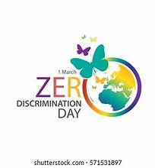

***COVID-19 AND INEQUALITIES***

* Almost 130 countries, with 2.5 billion people, are yet to administer a single dose of a COVID-19 vaccine, including most countries in Africa.
* Uganda will pay US$ 7 per dose of the AstraZeneca vaccine, South Africa will pay more than US$ 5, which is double what the European Union will pay (just over US$ 2 per dose).
* Nine million lives were lost over the six years when antiretroviral therapy was not available to people in poorer countries because of its high price.
* The World Bank expects the number of newly impoverished people to rise from 88 million–115 million in 2020 to 119 million–124 million in 2021 as a result of the COVID-19 pandemic.

